Game Design Document

Fill up the following document

1. Write the title of your project.

Pirate Game

1. What is the goal of the game?

To kill the pirates and save the city

1. Write a brief story of your game.

Some pirates try to attack a city but the guards must use their giant

Canon to try and fight off the pirates and protect their city.

1. Which are the playing characters of this game?

* Playing characters are the ones who respond to the user based on the input from the user.
* Cars, monkeys, dinos, wizards, etc., are the playing characters in the game.

|  |  |  |
| --- | --- | --- |
| Number | Character Name | What can this character do? |
| 1 | Canon | It can fire canon balls |
| 2 |  |  |
| 3 |  |  |
| 4 |  |  |
| 5 |  |  |
| 6 |  |  |
| 7 |  |  |
| 8 |  |  |

1. Which are the Non-Playing Characters of this game?

* Non-Playing characters are the ones that don't have an action or behavior when the user interacts with the game.
* Hurdles, stones, bananas, coins, etc., are non-playing characters in the game.

|  |  |  |
| --- | --- | --- |
| Number | Character Name | What can this character do? |
| 1 | Boats |  |
| 2 | Pirates | They can ride the boats |
| 3 |  |  |
| 4 |  |  |
| 5 |  |  |
| 6 |  |  |
| 7 |  |  |
| 8 |  |  |

Draw your imagination of this game. What does this game look like?

* Draw the game either on your computer or on paper.
* Add images of the game scenes to show each of the playing and non-playing characters at least once.

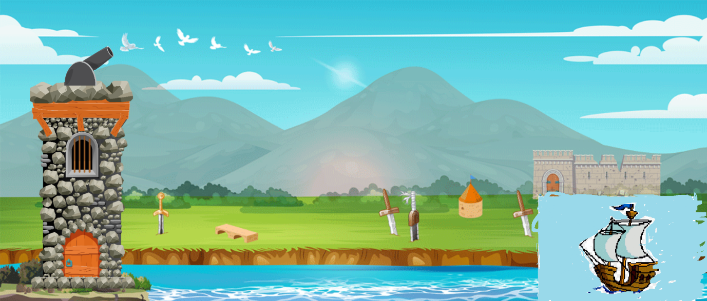

How do you plan to make your game engaging?

The player will have to aim properly at the boats to try and protect the

City. And the player will only has a specific number of canonballs to use.

If the player runs out of the canonballs, they lose the game.